Converting Pocket Topo files to Therion
Guide written by an Idiot

This note describes how to use <TopParser.exe> program under Windows.

TopParser is a program written to convert a PocketTopo file into Therion, producing, all the files necessary to draw a cave survey. It will also automatically run X-Therion and produce a 3d file.

It is an executable file that does not require installing on a Windows computer. You do need to keep it in the same directory as all the ancillary files that come zipped with it, though.

This means that you cannot simply click on a Pocket Topo file and run the program from there but you must, rather, run the .exe file and then give it a file to process. The location of this file does not matter. It can be, for example, on a portable device, usb drive or anywhere on the computer. In the example here, it is simply in a folder named test on my desktop.

An output directory does need to exist as well. If this particular survey is part of a larger survey of a cave system then the output directory needs to be the cave survey project directory. The program will generate all necessary sub directories.

Thus in the example shown, the .top file to be processed is called test.top and is in a folder on my desktop: C:\Users\Graham\Desktop\test\test.top
As ‘test’ is part of the overall survey of a cave called ‘cave’ the project folder is called ‘cave’ and is also on my desktop C:\Users\Graham\Desktop\cave

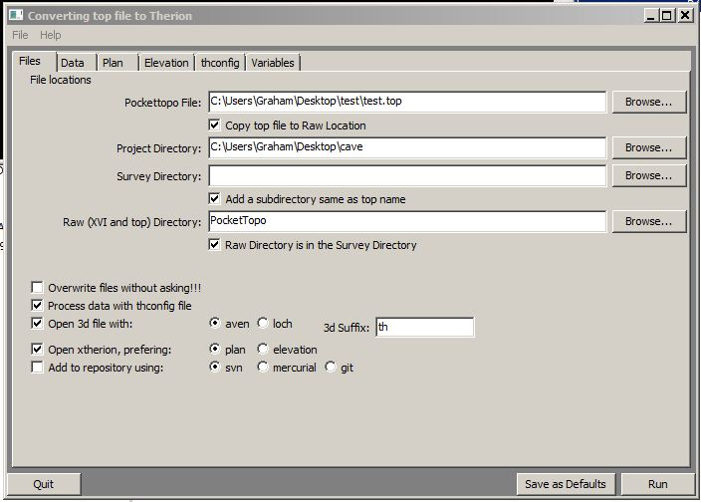
Having run the TopParser.exe and browsed for the two locations, source and output, we have a window on screen looking like the screen shot above. There is also a blank command line window which can be safely ignored. This is actually, all that is needed as with the boxes ticked as shown, the th, th2 (both plan and extended elevation) and thconfig files will be produced and placed in the subdirectory ‘test’ A copy of the .top file along with the generated plan and elevation ‘xvi files will be placed in a further subdirectory ‘PocketTopo’ this ensures that the raw data is automatically archived.

The output subdirectory will thus look like this:

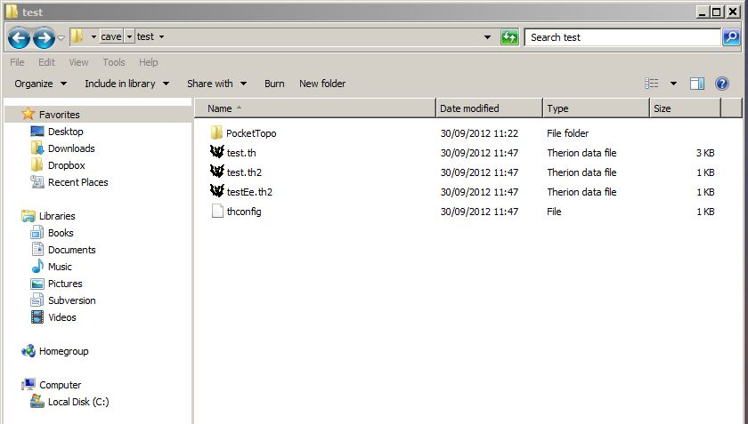

All being well, X-therion will also have run, produced an output Survex .3d file and opened it in Aven as well. This does depend, however, on what is in the thconfig file. See below.

The second tab on the TopParser window ‘Data’controls the elements of the th file. These should be self-explanatory to anyone used to using Therion.

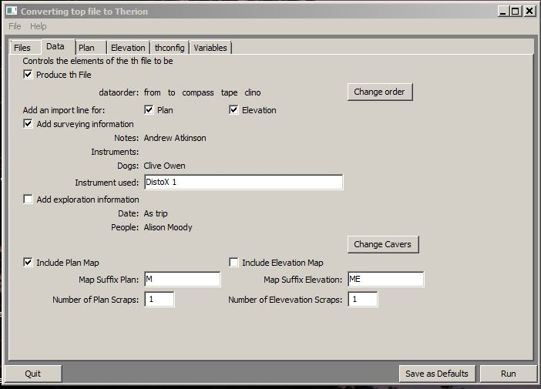

The ‘change order’ button produces a box with one button, pressing that button a given number of times will move the first element in the dataorder list along by that number of places. If you really want to, that is.

The third and fourth tabs control the elements of the plan and elevation th2 files. The naming conventions shown are those used by us in the Cheddar catchment project and elsewhere. The variables most likely to need changing here are those controlling the scale, depending on how much cave has actually been surveyed.

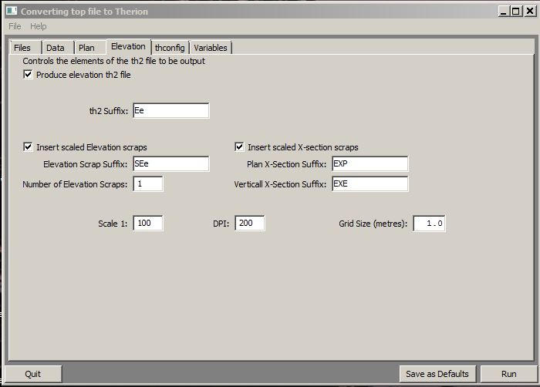

The fifth tab controls the thconfig file. It essentially produces a simple thconfig with commands to output various types of file. This should be familiar to anyone using Therion. This is not the place to discuss these, save to say that by default this thconfig requires a layout file. It may be best to comment that out initially.

The sixth tab simply controls the default locations of the various parts of Survex and Therion. Most windows users will not need to do anything here.

Having set (or ignored) these variables, go back to the first tab and press “run”

